Phone Book Management System

DOCUMENT CHANGE RECORD SHEET

Date | Versions | Description
10/08/2025 | 1.0 | Documentation Development
15/08/2025 | 1.0 | Đặt tả Functional Requirements and Non-Functional Requirements
19/08/2025 | 1.0 | Update Data Flow Diagram, Use case Diagram, Class Diagram, Data Model, Interface Design Description
21/08/2025 | 1.1 | Update Data Flow Diagram, Use case Diagram, Class Diagram, Data Model, Interface Design Description
22/08/2025 | 1.2 | Update Class Diagram, Data Model, Interface Design Description

- Phone Book Management System
The Phone Book online contact management system is built to support customers to manage, classify and retrieve contact information in the easiest, safest and most optimal way. The system includes the following detailed functions:
- Add and manage contacts:
  - Customers can select the function of adding a new contact and enter the details including: first and last name, primary phone number, email address, home address, and select the corresponding classification group. The system will check the data format (e.g. phone number in correct number format, correct email syntax) before storing it in the database. If the data is valid, the system saves a new record and displays a success message; If the data is invalid or missing the required fields, the system marks an error and asks the customer to re-enter it.
  - Customers can select a specific contact from the list to edit the information. The system displays a form containing the contact's current data for the customer to change the required fields. When the customer presses confirm the update, the system checks the validity of the new information and overwrites the data to the database, and at the same time gives a notification of the operation result.
  - Customers can choose to remove one or more contacts from their contacts. In order to avoid confusion, the system always displays a confirmation window (pop-up) asking customers if they are sure they want to delete it or not. If the customer agrees, the system will remove the record from the database and update the list again; If the customer cancels, then the deletion is stopped.
- View and search for contacts:
  - Customers can view a list of all contacts in their contacts as a list or pagination. The system automatically retrieves data from the database and displays full summary information including full name, phone number, group, and favorite flag. In case the contacts do not have data yet, the system will display the message "No contacts yet" to guide customers to create a new one.
  - Customers can search for quick contacts by entering keywords containing their full name, phone number, or email address in the search bar. The system scans the entire database and returns a list of matching results or containing the corresponding keyword. Customers can also incorporate filters such as grouping filtering or alphabetical (A-Z) sorting for easy lookup.
- Categorize groups and manage favorites:
  - Customers can manage contact groups by initializing new groups (enter group names and descriptions), editing group names, or deleting groups that no longer need to be used (e.g., Family, Colleagues, Customers). Customers can assign a contact to one or more groups at the same time to facilitate work and life management.
  - Customers can flag favorites for important contacts or frequently interact with them through the star icon right in the list. The system records the status and provides its own screen to help customers quickly filter and view a list of their favorite contacts.
- Account management and security:
  - The customer logs in to the system with a username and personal password. The system is responsible for checking and comparing credentials in the database before granting customers permission to access their own contact management page.
  - Customers can actively change their passwords by entering their current passwords and new passwords to ensure information security. In addition, customers can choose to log out to end the session, the system will delete the session information and return to the login screen.

- Glossary
- Contact: A contact's personal stored information, including their full name, phone number, email, address, and classification group.
- Group: A user-defined classification label for grouping contacts with the same attributes (such as Colleagues, Family, Friends).
- Favorite Contact: Priority flags help users quickly access important contacts.
- Account: User/Admin's identification information to log in and secure the personal data area.

- Supplementary Specification

Usability
The interface adjusts itself according to the device screen size (Responsive Design).

Reliability
The system must operate continuously 24/7 with reliability that reaches .$>99.9\%$

Performance
The system is capable of responding to 10,000 customers accessing simultaneously. Capable of storing customer information and orders/contact records.$500.000+1.000.000+$

Supportability
None

Security
Customers are only allowed to view and manage information and data under their own ownership. Avoid SQL Injection, XSS security errors. Use solutions to avoid automated software flooding data

Development requirement
Use the MySQL database management system. C++ Development Language. Server Centos 6.0.

- Data Flow
1. Overall Diagram
1.1. List of Components
External Entity
User: The person who uses the phone book management system.
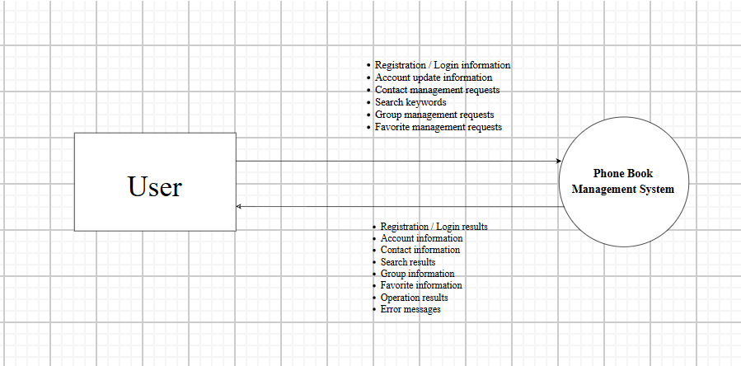
Processes
- 1.0 Account Management – Manage user accounts.
- 2.0 Contact Management – Manage contacts.
- 3.0 Search for Contacts – Search for contacts.
- 4.0 Group Management – Manage contact groups.
- 5.0 Favorite Management – Manage favorite contacts.
Data Stores
- D1 – Account: Stores account information.
- D2 – Contact: Stores contact information.
- D3 – Group: Stores group information.
- D4 – Favorite: Stores information about favorite contacts.
Data Flows
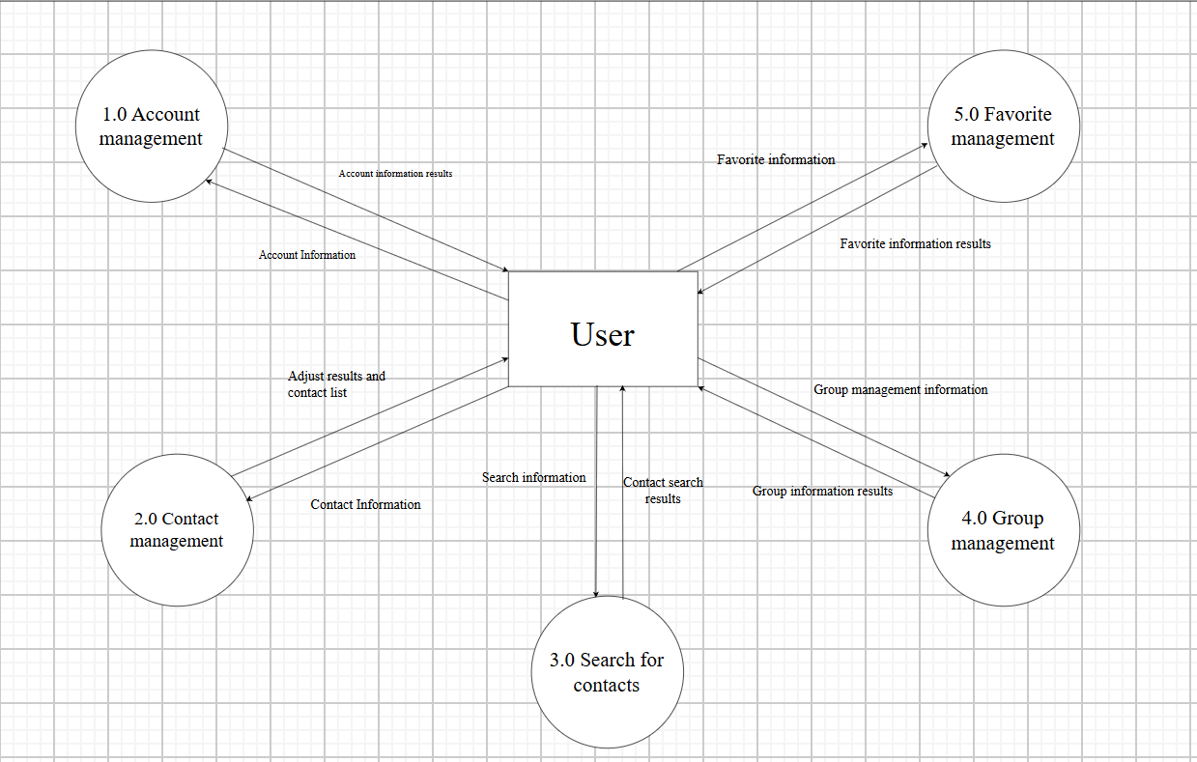
The Main Data Flows Include
1. Account Management
- Account information results
- Account information
2. Contact Management
- Contact information
- Adjust results and contact list
3. Search for Contacts
- Search information
- Contact search results
4. Group Management
- Group information
- Group information result
5. Favorite Management
- Favorite information
- Favorite information results
2. Data Flow 1: Account Management
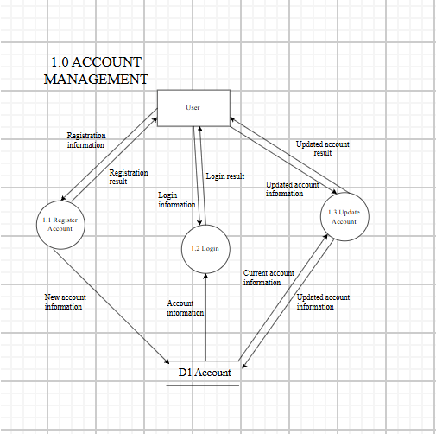
2.1. Summary
The Account Management data flow is used to manage user account information, including account registration, login, and account information updates.
2.2. Components Involved
- External Entity: User
- Process: 1.0 Account Management
- Data Store: D1 – Account
- Data Flows:
  - Registration information
  - Registration result
  - Login information
  - Login result
  - Updated account information
  - Account information
  - Update result
2.3. Data Flow
Account Registration
User
↓ Registration information
1.1 Register Account
↓ New account information
D1 – Account
↓ Registration result
User
Account Login
User
↓ Login information
1.2 Login
↕
D1 – Account
↓ Account information
1.2 Login
↓ Login result
User
Account Update
User
↓ Updated account information
1.3 Update Account
↕
D1 – Account
↓ Account information
1.3 Update Account
↓ Update result
User
2.4. Input Data
The user provides:
- Registration information
- Login information
- Updated account information
Account information may include the username, password, and other necessary personal information.
2.5. Data Processing
The system:
- Receives the registration information.
- Validates the account information.
- Stores the account in D1 – Account.
- Verifies the login information against the stored account data.
- Allows the user to update account information.
- Updates the corresponding data in D1 – Account.
2.6. Output Data
The system returns:
- Registration result
- Login result
- Account information
- Update result
2.7. Conditions and Constraints
- Registration information must be complete.
- The account must not duplicate an existing account identifier.
- Login information must match the data stored in D1 – Account.
- Updated information must be valid before being stored.
3. Data Flow 2: Contact Management
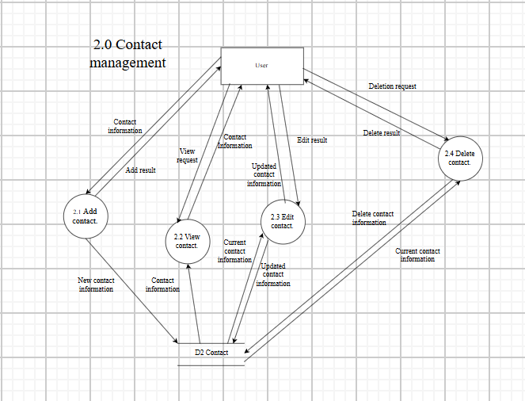
3.1. Summary
The Contact Management data flow is used to manage contacts in the phone book, including adding, viewing, editing, and deleting contacts.
3.2. Components Involved
- External Entity: User
- Process: 2.0 Contact Management
- Data Store: D2 – Contact
- Data Flows:
  - New contact information
  - Contact information
  - Contact update information
  - Delete contact request
  - Contact list
  - Contact details
  - Add result
  - Edit result
  - Delete result
3.3. Data Flow
Add Contact
User
↓ New contact information
2.1 Add Contact
↓ New contact information
D2 – Contact
↓ Add result
User
View Contact
User
↓ View request
2.2 View Contact
↕
D2 – Contact
↓ Contact details
User
Edit Contact
User
↓ Contact update information
2.3 Edit Contact
↕
D2 – Contact
↓ Edit result
User
Delete Contact
User
↓ Delete contact request
2.4 Delete Contact
↓ Delete contact information
D2 – Contact
↓ Delete result
User
3.4. Input Data
- New contact information
- View request
- Contact update information
- Delete contact request
Contact information may include:
- Name
- Phone number
- Email
- Group
3.5. Data Processing
The system:
- Receives contact information.
- Validates the data.
- Stores the new contact in D2 – Contact.
- Retrieves contact information when the user requests to view it.
- Updates contact information when the user edits it.
- Deletes the contact when the user submits a delete request.
3.6. Output Data
- Contact list
- Contact details
- Add result
- Edit result
- Delete result
- Error message if the operation is invalid
3.7. Conditions and Constraints
- Contact information must be valid.
- Required information must not be missing.
- The contact must be identifiable before performing an Edit/Delete operation.
- Only authorized users can modify their contact data.
4. Data Flow 3: Search for Contacts
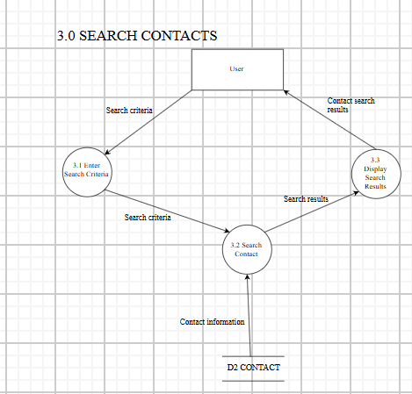
4.1. Summary
The Search for Contacts data flow allows users to search for contacts in the phone book based on criteria such as name, phone number, email, or group.
4.2. Components Involved
- External Entity: User
- Process: 3.0 Search for Contacts
- Data Store: D2 – Contact
- Data Flows:
  - Search criteria
  - Contact information
  - Search results
  - Contact search results
4.3. Data Flow
User
↓ Search criteria
3.1 Enter Search Criteria
↓ Search criteria
3.2 Search Contact
↕
D2 – Contact
↓ Search results
3.3 Display Search Results
↓ Contact search results
User
4.4. Input Data
The user enters:
- Name
- Phone number
- Email
- Group
These pieces of information are transmitted as Search criteria.
4.5. Data Processing
The system:
- Receives the search criteria.
- Identifies the information to be searched.
- Retrieves data from D2 – Contact.
- Compares contact data with the search criteria.
- Collects matching contacts.
- Displays the search results.
4.6. Output Data
- Search results
- Contact search results
If matching data is found, the system displays a list of suitable contacts.
4.7. Conditions and Constraints
- Search criteria must be valid.
- The user can search using one or multiple criteria.
- If no matching contact is found, the system returns an empty result or an appropriate notification.
5. Data Flow 4: Group Management
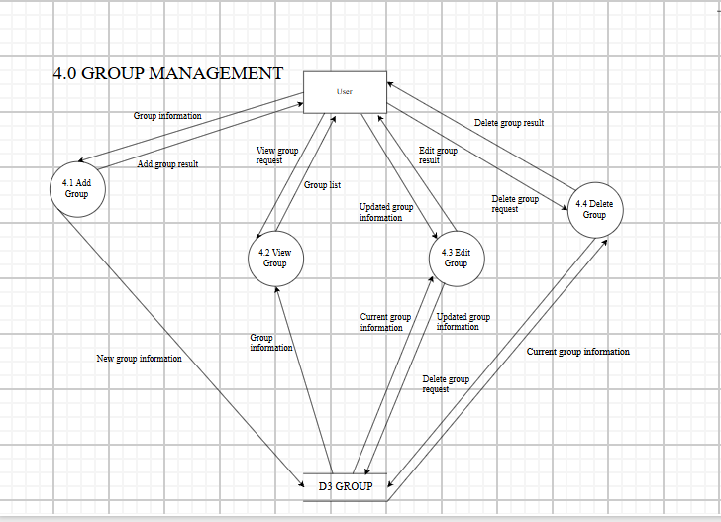
5.1. Summary
The Group Management data flow allows users to organize contacts into groups for easier management.
The operations include:
- Add group
- View group
- Edit group
- Delete group
5.2. Components Involved
- External Entity: User
- Process: 4.0 Group Management
- Data Store: D3 – Group
- Data Flows:
  - New group information
  - View group request
  - Edit group request
  - Delete group request
  - Group information
  - Group list
  - Add group result
  - Edit group result
  - Delete group result
5.3. Data Flow
Add Group
User
↓ New group information
4.1 Add Group
↓ New group information
D3 – Group
↓ Add group result
User
View Group
User
↓ View group request
4.2 View Group
↕
D3 – Group
↓ Group list
User
Edit Group
User
↓ Edit group request
4.3 Edit Group
↕
D3 – Group
↓ Edit group result
User
Delete Group
User
↓ Delete group request
4.4 Delete Group
↓ Delete group information
D3 – Group
↓ Delete group result
User
5.4. Input Data
- New group information
- View group request
- Edit group request
- Delete group request
5.5. Data Processing
The system:
- Receives group information from the User.
- Validates the group information.
- Stores the new group in D3 – Group.
- Retrieves the group list.
- Updates group information.
- Deletes the group according to the user's request.
5.6. Output Data
- Group information
- Group list
- Add group result
- Edit group result
- Delete group result
5.7. Conditions and Constraints
- The group name must be valid.
- Duplicate group names should not be allowed within the same account.
- The group must exist before performing an Edit/Delete operation.
- Only the User who owns the group is allowed to modify it.
6. Data Flow 5: Favorite Management
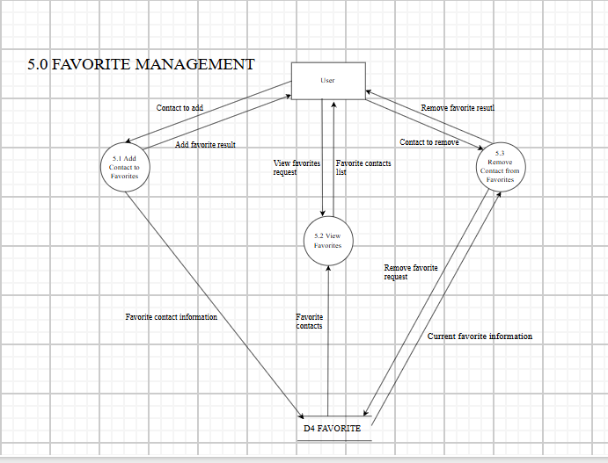
6.1. Summary
The Favorite Management data flow allows users to mark important contacts as favorites, view the favorite contacts list, and remove contacts from the favorites list.
6.2. Components Involved
- External Entity: User
- Process: 5.0 Favorite Management
- Data Store: D4 – Favorite
- Data Flows:
  - Contact to add
  - View favorites request
  - Contact to remove
  - Remove favorite request
  - Favorite contacts list
  - Add favorite result
  - Remove favorite result
6.3. Data Flow
Add Contact to Favorites
User
↓ Contact to add
5.1 Add Contact to Favorites
↓ Favorite contact information
D4 – Favorite
↓ Add favorite result
User

View Favorite Contacts
User
↓ View favorites request
5.2 View Favorites
↕
D4 – Favorite
↓ Favorite contacts
User
Remove Contact from Favorites
User
↓ Remove favorite request
5.3 Remove Contact from Favorites
↓ Remove favorite information
D4 – Favorite
↓ Remove favorite result
User
6.4. Input Data
- Contact to add
- View favorites request
- Contact to remove
- Remove favorite request
6.5. Data Processing
The system:
- Receives the contact that the User wants to add to favorites.
- Stores the favorite information in D4 – Favorite.
- Retrieves the favorite contacts list when requested by the User.
- Identifies the contact to be removed.
- Removes the contact from D4 – Favorite.
6.6. Output Data
- Favorite contacts list
- Add favorite result
- Remove favorite result
6.7. Conditions and Constraints
- The contact must exist before it can be added to favorites.
- A contact should not be added multiple times to the favorites list.
- The contact must exist in the favorites list before it can be removed.
- Only the User who owns the favorites list is allowed to modify it.

- Usse Case
1. Overview Diagram
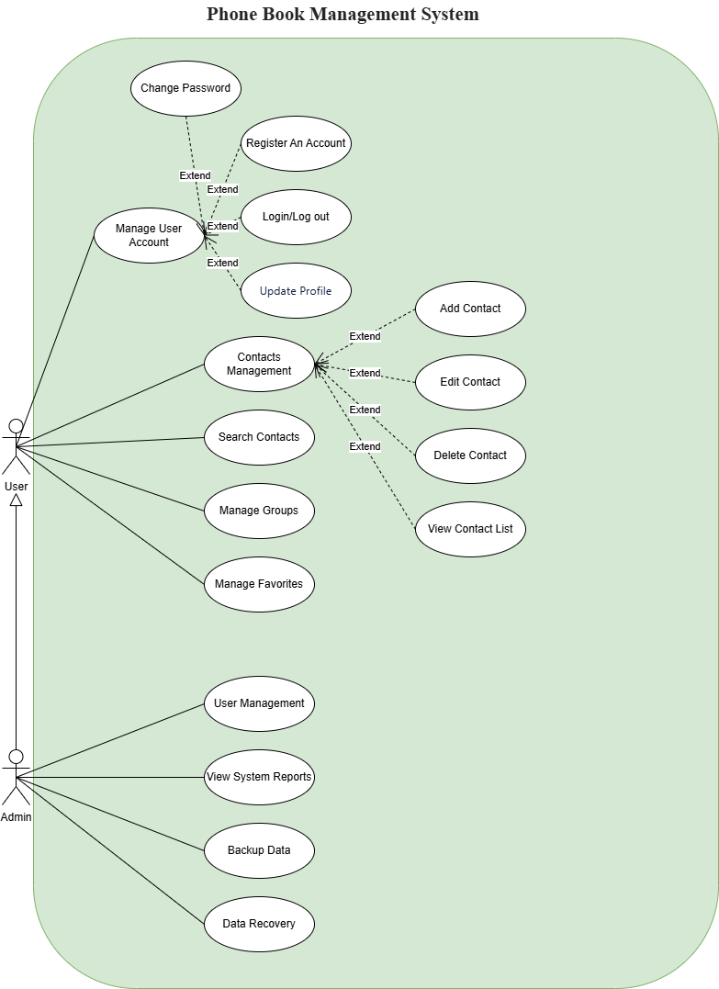

1.1. List of Actors
STT | Actor | Meaning
1 | User | Users use the system to manage personal accounts and contacts.
2 | Admin | System administrators, who have permission to manage users and view system reports.

1.2. List of Use Cases
STT | Use Case | Meaning
1 | Manage User Account | User Account Management
2 | Change Password | Change your password
3 | Register An Account | Register an account
4 | Login/Log out | Login/Logout
5 | Update Profile | Updating personal information
6 | Contacts Management | Manage your contacts
7 | Add Contact | Add a contact
8 | Edit Contact | Edit a contact
9 | Delete Contact | Delete a contact
10 | View Contact List | View contact list
11 | Search Contacts | Search for contacts
12 | Manage Groups | Contact Group Management
13 | Manage Favorites | Manage Favorite Contacts
14 | User Management | User Management
15 | View System Reports | View system reports
16 | Backup Data | Back up your data
17 | Data Recovery | Data Recovery

1.3. Relationship between Use Cases
According to the diagram:
- Manage User Account extends:
  - Register An Account
  - Login/Log out
  - Change Password
  - Update Profile
- Contacts Management extends:
  - Add Contact
  - Edit Contact
  - Delete Contact
  - View Contact List
- Admin inherits from User.

2. Use Case: Manage User Account

2.1. Summary
This use case allows the User to manage their account.

2.2. Event Flow

2.2.1. Main Event Flow
- The User selects Manage User Account.
- The system displays the account management functions.
- The User selects a function.
- The system performs the selected function.
- The system displays the result.

2.2.2. Other Event Flow
If the information is invalid, the system displays an error message and asks the User to try again.

2.3. Special Requirements
Account information and passwords must be protected.

2.4. System Status Before Starting
The User can access the account management function.

2.5. System Status After Implementation
The account information is updated according to the User's action.

2.6. Extension Points
- Register An Account
- Login/Log out
- Change Password
- Update Profile

3. Use Case: Change Password

3.1. Summary
This use case allows the User to change the account password.

3.2. Event Flow

3.2.1. Main Event Flow
- The User selects Change Password.
- The system asks for the current password and new password.
- The User enters the required information.
- The system checks the information.
- The system changes the password.
- The system displays the result.

3.2.2. Other Event Flow
If the current password or new password is invalid, the system displays an error message.

3.3. Special Requirements
The password must be protected and secure.

3.4. System Status Before Starting
The User has an account.

3.5. System Status After Implementation
The new password is saved successfully.

3.6. Extension Points
None.

4. Use Case: Register An Account

4.1. Summary
This use case allows the User to register a new account.

4.2. Event Flow

4.2.1. Main Event Flow
- The User selects Register An Account.
- The system displays the registration form.
- The User enters the required information.
- The system checks the information.
- The system creates the new account.
- The system displays the registration result.

4.2.2. Other Event Flow
If the information is invalid or the account already exists, the system displays an error message.

4.3. Special Requirements
The account information and password must be stored securely.

4.4. System Status Before Starting
The User does not have an account.

4.5. System Status After Implementation
A new account is created successfully.

4.6. Extension Points
None.

5. Use Case: Login/Log out

5.1. Summary
This use case allows the User to log in to or log out of the system.

5.2. Event Flow

5.2.1. Main Event Flow
- The User selects Login/Log out.
- The system asks for the account information.
- The User enters the username and password.
- The system checks the information.
- If the information is correct, the User can access the system.
- When the User selects log out, the system ends the session.

5.2.2. Other Event Flow
If the login information is incorrect, the system displays an error message.

5.3. Special Requirements
The login information and password must be protected.

5.4. System Status Before Starting
The User is not logged in.

5.5. System Status After Implementation
The User is logged in or logged out according to the selected action.

5.6. Extension Points
None.

6. Use Case: Update Profile

6.1. Summary
This use case allows the User to update personal information.

6.2. Event Flow

6.2.1. Main Event Flow
- The User selects Update Profile.
- The system displays the current profile information.
- The User changes the information.
- The User saves the changes.
- The system checks the information.
- The system updates the profile.
- The system displays the result.

6.2.2. Other Event Flow
If the information is invalid, the system displays an error message.

6.3. Special Requirements
Only the account owner can update their profile.

6.4. System Status Before Starting
The User is logged in.

6.5. System Status After Implementation
The personal information is updated.

6.6. Extension Points
None.

7. Use Case: Contacts Management

7.1. Summary
This use case allows the User to manage contacts.

7.2. Event Flow

7.2.1. Main Event Flow
- The User selects Contacts Management.
- The system displays the contact management functions.
- The User selects a function.
- The system performs the selected function.
- The system displays the result.

7.2.2. Other Event Flow
If the operation is invalid, the system displays an error message.

7.3. Special Requirements
The User can only manage their own contacts.

7.4. System Status Before Starting
The User is logged in.

7.5. System Status After Implementation
The contact information is updated according to the User's action.

7.6. Extension Points
- Add Contact
- Edit Contact
- Delete Contact
- View Contact List

8. Use Case: Add Contact

8.1. Summary
This use case allows the User to add a new contact.

8.2. Event Flow

8.2.1. Main Event Flow
- The User selects Add Contact.
- The system displays the contact form.
- The User enters the contact information.
- The system checks the information.
- The system saves the new contact.
- The system displays the result.

8.2.2. Other Event Flow
If the information is invalid, the system displays an error message.

8.3. Special Requirements
Contact information must be valid before it is saved.

8.4. System Status Before Starting
The User is logged in.

8.5. System Status After Implementation
A new contact is added to the contact list.

8.6. Extension Points
None.

9. Use Case: Edit Contact

9.1. Summary
This use case allows the User to edit contact information.

9.2. Event Flow

9.2.1. Main Event Flow
- The User selects Edit Contact.
- The system displays the contact information.
- The User edits the information.
- The User saves the changes.
- The system checks the information.
- The system updates the contact.
- The system displays the result.

9.2.2. Other Event Flow
If the information is invalid, the system displays an error message.

9.3. Special Requirements
The User can only edit their own contacts.

9.4. System Status Before Starting
The contact already exists.

9.5. System Status After Implementation
The contact information is updated.

9.6. Extension Points
None.

10. Use Case: Delete Contact

10.1. Summary
This use case allows the User to delete a contact.

10.2. Event Flow

10.2.1. Main Event Flow
- The User selects a contact.
- The User selects Delete Contact.
- The system asks the User to confirm the deletion.
- The User confirms the deletion.
- The system deletes the contact.
- The system displays the result.

10.2.2. Other Event Flow
If the User does not confirm the deletion, the system does not delete the contact.

10.3. Special Requirements
The system should prevent accidental deletion of contacts.

10.4. System Status Before Starting
The contact exists in the contact list.

10.5. System Status After Implementation
The selected contact is deleted.

10.6. Extension Points
None.
Lưu ý: Confirm không được tạo thành một Use Case riêng vì sơ đồ của bạn không có oval Confirm.

11. Use Case: View Contact List

11.1. Summary
This use case allows the User to view the contact list.

11.2. Event Flow

11.2.1. Main Event Flow
- The User selects View Contact List.
- The system gets the contact list.
- The system displays the contact list.
- The User can view the contact information.

11.2.2. Other Event Flow
If there are no contacts, the system displays an empty contact list.

11.3. Special Requirements
Only the User's contacts are displayed.

11.4. System Status Before Starting
The User is logged in.

11.5. System Status After Implementation
The contact list is displayed.

11.6. Extension Points
None.

12. Use Case: Search Contacts

12.1. Summary
This use case allows the User to search for contacts.

12.2. Event Flow

12.2.1. Main Event Flow
- The User selects Search Contacts.
- The system displays the search function.
- The User enters a keyword.
- The system searches the contact list.
- The system displays the matching contacts.

12.2.2. Other Event Flow
If no contact matches the keyword, the system displays no matching results.

12.3. Special Requirements
The search is performed only in the User's contact list.

12.4. System Status Before Starting
The User is logged in.

12.5. System Status After Implementation
The matching contacts are displayed.

12.6. Extension Points
None.

13. Use Case: Manage Groups

13.1. Summary
This use case allows the User to manage contact groups.

13.2. Event Flow

13.2.1. Main Event Flow
- The User selects Manage Groups.
- The system displays the contact groups.
- The User selects a group.
- The User performs a group management action.
- The system updates the group information.
- The system displays the result.

13.2.2. Other Event Flow
If the operation is invalid, the system displays an error message.

13.3. Special Requirements
The User can only manage their own contact groups.

13.4. System Status Before Starting
The User is logged in.

13.5. System Status After Implementation
The contact group information is updated.

13.6. Extension Points
None.

14. Use Case: Manage Favorites

14.1. Summary
This use case allows the User to manage favorite contacts.

14.2. Event Flow

14.2.1. Main Event Flow
- The User selects Manage Favorites.
- The system displays the favorite contacts.
- The User selects a contact.
- The User adds or removes the contact from favorites.
- The system updates the favorite list.
- The system displays the result.

14.2.2. Other Event Flow
If the operation is invalid, the system displays an error message.

14.3. Special Requirements
The favorite list belongs to the current User.

14.4. System Status Before Starting
The User is logged in.

14.5. System Status After Implementation
The favorite contact list is updated.

14.6. Extension Points
None.

15. Use Case: User Management

15.1. Summary
This use case allows the Admin to manage users in the system.

15.2. Event Flow

15.2.1. Main Event Flow
- The Admin selects User Management.
- The system displays the user list.
- The Admin selects a user.
- The Admin performs a management action.
- The system processes the action.
- The system displays the result.

15.2.2. Other Event Flow
If the Admin does not have permission or the information is invalid, the system displays an error message.

15.3. Special Requirements
Only the Admin can use User Management.

15.4. System Status Before Starting
The Admin is logged in.

15.5. System Status After Implementation
The user information is updated according to the Admin's action.

15.6. Extension Points
None.

16. Use Case: View System Reports

16.1. Summary
This use case allows the Admin to view system reports.

16.2. Event Flow

16.2.1. Main Event Flow
- The Admin selects View System Reports.
- The system gets the report data.
- The system processes the data.
- The system displays the report.

16.2.2. Other Event Flow
If there is no report data, the system displays an appropriate message.

16.3. Special Requirements
Only the Admin can view system reports.

16.4. System Status Before Starting
The Admin is logged in.

16.5. System Status After Implementation
The system report is displayed.

16.6. Extension Points
None.

17. Use Case: Backup Data

17.1. Summary
This use case allows the Admin to back up system data.

17.2. Event Flow

17.2.1. Main Event Flow
- The Admin selects Backup Data.
- The system prepares the data.
- The system creates a backup.
- The system saves the backup data.
- The system displays the backup result.

17.2.2. Other Event Flow
If the backup process fails, the system displays an error message.

17.3. Special Requirements
Backup data must be stored safely.

17.4. System Status Before Starting
The system has available data to back up.

17.5. System Status After Implementation
A backup of the system data is created.

17.6. Extension Points
None.

18. Use Case: Data Recovery

18.1. Summary
This use case allows the Admin to recover system data from a backup.

18.2. Event Flow

18.2.1. Main Event Flow
- The Admin selects Data Recovery.
- The system displays the available backup data.
- The Admin selects a backup.
- The system checks the backup data.
- The system restores the data.
- The system displays the recovery result.

18.2.2. Other Event Flow
If the backup data is invalid or unavailable, the system displays an error message.

18.3. Special Requirements
The backup data must be valid and safely stored.

18.4. System Status Before Starting
A valid backup is available.

18.5. System Status After Implementation
The system data is recovered from the selected backup.

18.6. Extension Points
None.

- Class Diagram
- Class Diagram Overview
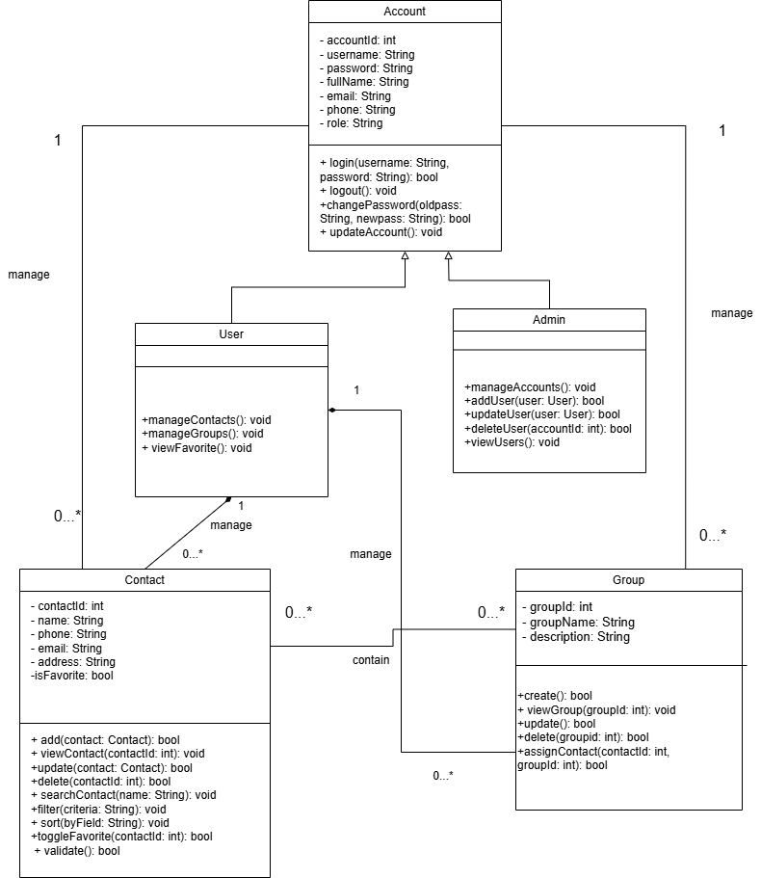
1.1. List of classes
Based on the Class Diagram, the current system consists of the following main classes:
- Account
- User
- Admin
- Contact
- Group
The general role of classes
- Account: The base layer stores account information and provides functions related to login, logout, and account updates.
- User: Inherited from Account, represents regular users and provides the functions of managing Contacts, Groups and viewing favorite Contacts.
- Admin: Inherited from the Account, represents the administrator and has the right to manage the User account.
- Contact: Saves a contact's information and provides the functions of adding, editing, deleting, searching, filtering, and sorting Contacts.
- Group: Saves group information and provides functions to create, edit, delete, view Groups, and assign contacts to Groups.
1.2. Relationships between classes
Class Diagram uses the following main types of relationships:
- Inheritance: Users and Admins inherit from Accounts.
- Association: Accounts that have a management relationship with Contacts and Groups; Contacts have a relationship with Groups.
- Composition: The User owns the Contact and Group by the Composition relationship, represented by a solid diamond on the User side.
2. Class Account
2.1. Class description
- Account is the base layer of the system, used to store the general information of an account.
- This layer provides basic account-related functions such as logging in, logging out, changing passwords, and updating account information.
- Account serves as the parent class for the User and Admin classes.
2.2. Properties
Attributes are set at the private level, represented by the - sign in the Class Diagram.

Attributes | Data types | Meaning
accountId | int | Account identifier
username | string | Username
password | string | Password
fullName | string | Full name
Email | string | Email Address
Phone | string | Phone Number
Role | string | The role of the account

2.3. Method

Method | Return Type | Meaning
login(username: String, password: String) | Anonymous | Check the information and perform the login
logout() | Void | Log out of your account
changePassword(oldpass: String, newpass: String) | Anonymous | Change your password
updateAccount() | Void | Account Updates

3. Class User
3.1. Class description
- User represents the regular user of the system.
- The User inherits from the Account, so the User can use the general information and functions of the account such as username, password, email, login and logout.
- In addition, users have additional functions to manage Contacts, manage Groups and view Contacts marked as favorites.
3.2. Properties
In the current Class Diagram, the User does not declare any additional attributes of their own.
The common attributes of the User are inherited from the Account class.
3.3. Method

Method | Return Type | Meaning
manageContacts() | Void | Manage your contact list
manageGroups() | Void | Manage Groups
viewFavorite() | Void | View Favorite Contacts

4. Class Admin
4.1. Class description
- Admin represents the administrator of the system. The Admin inherits from the Account, so the Admin also has the basic information and functions of an account.
- Unlike Users, Admins have the right to manage User accounts, including adding, updating, deleting, and viewing User lists.
4.2. Properties
In the current Class Diagram, the Admin does not have its own properties. Admins use attributes inherited from Accounts.
4.3. Method

Method | Return Type | Meaning
manageAccounts() | Void | Account Management
addUser(user: User) | Anonymous | Add a new user
updateUser(user: User) | Anonymous | Updating User Information
deleteUser(accountId: int) | Anonymous | Deleting a User Based on Account ID
viewUsers() | Void | View User List

5. Class Contact
5.1. Class Description
- A contact represents a contact that is stored in the system.
- This layer stores information such as contact codes, names, phone numbers, emails, addresses, and favorites.
- In addition to storing data, Contact also contains functions that handle contact lists such as adding, viewing, updating, deleting, searching, filtering, sorting, and marking favorites.
5.2. Properties

Attributes | Data types | Meaning
contactId | int | Mã Contact
name | string | The name of the contact
phone | string | Phone Number
email | string | Email Address
address | string | Address
isFavorite | bool | Determine whether a contact is popular or not

5.3. Method

Method | Return Type | Meaning
add(contact: Contact) | Anonymous | Thêm contact
view(contactId: int) | void | View Contact
update(contact: Contact) | bool | Contact Updates
delete(contactId: int) | bool | Xóa Contact
search(keyword: String) | Void | Search for contacts
filter(criteria: String) | Void | Filter contacts by condition
sort() | Void | Organize your contact list
toggleFavorite(contactId: int) | Anonymous | Change your favorite status

6. Class Group
6.1. Class description
- Group represents a Contact group.
- Each Group has a group ID, group name, and description. This class provides the functions of creating, viewing, updating, deleting Groups, and assigning contacts to Groups.
6.2. Properties

Attributes | Type of data | Meaning
groupId | int | Group Code
groupName | string | Team Name
description | string | Group Description

6.3. Method

Method | Return Type | Meaning
create() | Anonymous | Create a group
viewGroup(groupId: int) | Void | View Group List
update | Anonymous | Group Updates
delete(groupId: int) | Anonymous | Delete a Group
assignContact(contactId: int, groupId: int)  Anonymous | Anonymous | Assign a Contact to a Group

7. Describe relationships
7.1. Inheritance
The relationship of inheritance is expressed between:
- User → Account
- Admin → Account
Meaning:
The account contains the general characteristics of the account.
User and Admin are two different types of accounts that should be inherited from Accounts.
For example:
- The account has a username, password, email.
- The user reuses those attributes and adds the Contact/Group management function.
- Admin reuses those attributes and adds user management functionality.
Therefore, there is no need to re-declare the common attributes in User and Admin.
Here's the is-a relationship:
- User is an Account.
- Admin is an Account.
7.2. Association
Association is used to represent how the classes are related to each other.
Account – Contact
In the diagram, the Account is linked to the Contact with the manage label.
Multiplicity expressed:
Account 1 ───────── 0..* Contact
- An account can manage 0 or more Contacts.
- Each contact in this relationship is associated with 1 account.
It can be simply understood that an account can save and manage multiple contacts.
Account – Group
Similarly, the diagram shows:
Account 1 ───────── 0..* Group
- An account can manage 0 or more Groups.
- A Group belongs to an account in this relationship.
7.3. Composition
The composition relationship is represented by a rhombus with a color (◆). In the diagram, the User has a Composition relationship with the Contact and Group, with a solid diamond on the User's side.
User – Contact
User ◆──────── 0..* Contact
1
- A user can have multiple Contacts.
- A user may not have any contacts.
- Contact is a component that belongs to the user.
- When a User is deleted, the User's contacts are also considered deleted according to the User's lifecycle.
User – Group
Similar:
User ◆──────── 0..* Group
1
A user can have multiple groups. Groups are components that belong to the user and have a lifecycle that depends on the user.
8. Summarize relationships
Relations | Classes | Meaning
Inheritance | User – Account | User is a type of account
Inheritance | Admin – Account | Admin is a type of account
Association | Account – Contact | Account Manager Contact
Association | Account – Group | Account Management Group
Composition | User – Contact | User Owned 0..* Contact
Composition | User – Group | User owns 0..* Group
Association | Contact – Group | Groups containing Contacts

- Data Model
1. Overview Data Model Diagram
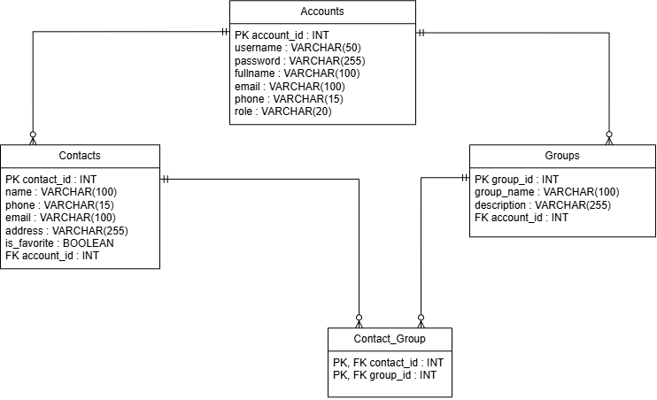
1.1. List of tables
The system consists of 04 main boards:
- Accounts: Stores user account information.
- Contacts: Stores a list of contact information.
- Groups: Stores a list of groups that categorize contacts.
- Contact_Group: The intermediate table that manages the link between contacts and groups.
1.2. Relationships between tables
Description of the relationship between tables:
• Accounts – Contacts: Relationship 1 – Many (1–N). An account owns multiple contacts.
• Accounts – Groups: Relationship 1 – Many (1–N). An account owns multiple groups.
• Contacts – Groups (via Contact_Group): Many-Many-Many(N–N) relationships. A contact can be in multiple groups, and a group contains multiple contacts.
1.3. Why design according to this model
Each Contact and Group is associated with a specific account (via account_id) to ensure privacy: users only see and operate on contacts and groups created by themselves, cannot access the data of other accounts. The N–N relationship between Contacts and Groups is separated into an intermediate table Contact_Group because a contact can belong to many different groups (for example, both the "Family" group and the "Coworkers" group), which a typical 1–N relationship does not represent.
2. Accounts table
2.1. Summary
The Accounts table is used to store login information, personal information and decentralize user accounts on the system.
2.2. Data Structure
2.2.1. Table structure
Column | Data Type | Constraint | Note
account_id | INT | PRIMARY KEY | Unique account identifier
username | VARCHAR(50) | NOT NULL, UNIQUE | Login username
password | VARCHAR(255) | NOT NULL | Hashed account password
fullname | VARCHAR(100) | NOT NULL | User's full name
email | VARCHAR(100) | UNIQUE | User's email
phone | VARCHAR(15) | NULL | User's phone number
role | VARCHAR(20) | NOT NULL, DEFAULT 'user' | Account role: user/admin

2.2.2. Detailed explanation of data fields
• account_id: A unique identifier for each account, which serves as the primary key for the system to distinguish and query quickly. The value is auto-increment, so users do not need to enter it, avoiding duplication.
• username: The username used for authentication. UNIQUE binding ensures that there are no two accounts with the same login name; NOT NULL because this is required to log in.
• password: Save encrypted passwords (hash), not plain text. The length of 255 characters is enough to contain common hash strings (bcrypt, SHA-256). Do not set UNIQUE because two users can accidentally match the same password without compromising business or security.
• fullname: Full name, used to display on the interface. Do not set UNIQUE as many users may have the same name.
• Email: Contacts, which can be used to recover passwords. Set UNIQUE so that each email is tied to only one account, avoiding conflicts when authenticating via email.
• phone: The contact phone number, which is not required to be entered because not all users provide it when registering.
• Role: Define the role (user/admin) for the system to decentralize access to the function. The default value 'user' ensures that the newly registered account does not inadvertently gain administrative rights.
2.3. Special requirements
• Two accounts with the same username or email are not allowed.
• Passwords are required to be encrypted before being saved to the database.
• Only Admins have the right to change the role field of another account.
2.4. System Status Before Starting
None. Accounts is the original table of the entire system, independent of data from any other table. The only condition is that the username and email (if any) declare do not exist in the system.
2.5. System status after implementation
A new Accounts record is created, or existing account information is updated. If an account is deleted, all Contacts and Groups belonging to that account are also deleted according to (ON DELETE CASCADE).
2.6. Extension Points
Fields such as avatar, created_at/updated_at, is_active (account activation status) can be added in the following versions.
3. Contacts Panel
3.1. Summary
The Contacts panel is used to store the details of each contact in the user's personal contacts.
3.2. Data Structure
3.2.1. Table structure
Column | Data Type | Constraint | Note
contact_id | INT | PRIMARY KEY | Unique contact identifier
name | VARCHAR(100) | NOT NULL | Contact name
phone | VARCHAR(15) | NOT NULL | Contact phone number
email | VARCHAR(100) | NULL | Contact email
address | VARCHAR(255) | NULL | Contact address
is_favorite | BOOLEAN | NOT NULL (Default: FALSE) | Favorite status
account_id | INT | NOT NULL, FOREIGN KEY REFERENCES Accounts(account_id) | Owner account

3.2.2. Detailed explanation of data fields
• contact_id: A unique identifier for each contact, which serves as the primary key.
• name: The name of the contact. Entry is required because this is the minimum information to identify a contact in the contacts.
• phone: The phone number of the contact. Import is required as this is the main purpose of the contacts manager app.
• Email: The contact's email, which is not required because not all contacts have this information available.
• address: The address of the contact, optional, saved only when the user provides more.
• is_favorite: Mark the contact as pinned to the favorites list or not. The default is FALSE when creating a new one, the user actively pops it up later.
• account_id: The foreign key refers to the Accounts.account_id, which account this contact belongs to. It is mandatory to NOT NULL because every contact must be tied to an account, ensuring data privacy between users.
3.3. Special requirements
• A contact belongs to only one account, not shared between different accounts.
• Users are only allowed to view, edit, and delete contacts of their own account.
3.4. System Status Before Starting
The account that owns the contact must already exist in the system before a contact record is created.
3.5. System status after implementation
A new contact is added to the account's contacts, or an existing contact is updated/deleted. If the contact is deleted, the corresponding link records in the Contact_Group are also deleted according to (ON DELETE CASCADE).
3.6. Extension Points
Fields such as avatar, birthday, and note can be added in later versions.
4. Groups Boards
4.1. Summary
Groups panels are used to store information about groups that categorize contacts set up by users.
4.2. Data Structure
4.2.1. Table structure
Column | Data Type | Constraint | Note
group_id | INT | PRIMARY KEY | Unique group identifier
group_name | VARCHAR(100) | NOT NULL | Group name
description | VARCHAR(255) | NULL | Group description
account_id | INT | NOT NULL, FOREIGN KEY REFERENCES Accounts(account_id) | Owner account

4.2.2. Detailed explanation of data fields
• group_id: A unique identifier for each group, which serves as the primary key.
• group_name: The name of the group (e.g., Family, Coworkers). Entry is required to differentiate groups from each other.
• description: Further description of the purpose or content of the group, optional.
• account_id: The foreign key references Accounts.account_id, which identifies which account created this group. NOT NULL is required because each group must always belong to a specific account.
4.3. Special requirements
• A group belongs to only one account.
• Users are only allowed to create, edit, and delete groups belonging to their own account.
4.4. System Status Before Starting
The account that owns the group must already exist in the system before a Group record is created.
4.5. System status after implementation
A new group is added to the system, or an existing group is updated/deleted. If the group is deleted, the corresponding link records in the Contact_Group are also deleted according to (ON DELETE CASCADE).
4.6. Extension Points
None.
5. Table Contact_Group (Intermediate Table)
5.1. Summary
The Contact_Group table serves as an intermediate table that connects Contacts and Groups, serving to assign a contact to one or more different groups.
5.2. Data Structure
5.2.1. Table structure
Column | Data Type | Constraint | Note
contact_id | INT | PRIMARY KEY, FOREIGN KEY REFERENCES Contacts(contact_id) | Contact reference
group_id | INT | PRIMARY KEY, FOREIGN KEY REFERENCES Groups(group_id) | Group reference

5.2.2. Detailed explanation of data fields
• contact_id: The foreign key references Contacts.contact_id, which determines which contacts are assigned to the group.
• group_id: The foreign key references Groups.group_id, which determines which group the contact is assigned to.
The contact_id and group_id columns together form the composite primary key of the table. This design ensures that each pair (contact_id, group_id) exists only once—that is, a contact cannot be duplicated in the same group multiple times.
5.3. Special Requirements
• A contact can appear in many different Contact_Group records (belonging to multiple groups).
• A group can appear in many different Contact_Group records (containing multiple contacts).
5.4. System Status Before Starting
Both the Contact and the linked Group must already exist in the system before a Contact_Group record is created.
5.5. System status after implementation
A new link between the Contact and the Group is established (or removed upon deletion). This doesn't change the original data in Contacts or Groups. When a Contact or Group is deleted, the corresponding link records in the Contact_Group are also deleted according to (ON DELETE CASCADE).
5.6. Extension Points
None.
6. Describe relationships
6.1. Accounts – Contacts
• An account can have multiple Contacts.
• Each contact belongs to an account.
• Contacts.account_id is the FK reference Accounts.account_id.
6.2. Accounts – Groups
• One account can create and own multiple Groups.
• Each Group belongs to a unique account.
• Groups.account_id is a Foreign Key (FK) that refers to Accounts.account_id.
6.3. Groups – Contact_Group
• A group can be associated with multiple records in a Contact_Group (which corresponds to how a group can contain multiple contacts inside).
• Each record in the Contact_Group refers to only one Group.
• Contact_Group.group_id is the Foreign Key (FK) that references the Groups.group_id.
6.4. Contacts – Contact_Group
• A contact can be associated with multiple records in a Contact_Group (which corresponds to a contact being able to be categorized into different groups).
• Each record in the Contact_Group refers to only one Contact.
• Contact_Group.contact_id is the Foreign Key (FK) that references the Contacts.contact_id.

VIII. Interface Design Description
1. Tổng quan về giao diện
1.1. Loại giao diện
Mô tả hệ thống sử dụng console interface, người dùng tương tác thông qua menu, bàn phím và các thông báo của hệ thống.
1.2. Nguyên tắc thiết kế giao diện
Mô tả ngắn gọn các nguyên tắc nhóm sử dụng, ví dụ:
- Menu rõ ràng, dễ hiểu.
- Các chức năng được phân nhóm.
- Có thông báo khi thao tác thành công/thất bại.
- Khi nhập dữ liệu không hợp lệ, hệ thống yêu cầu người dùng nhập lại.
2. Register Account Interface
2.1. Mô tả giao diện
- Giao diện Register An Account dành cho người dùng chưa có tài khoản và muốn đăng ký sử dụng hệ thống. Giao diện được thiết kế đơn giản, tập trung vào việc nhập thông tin tài khoản và tạo tài khoản mới.
- Giao diện này chỉ dành cho User mới, chưa đăng nhập vào hệ thống. Sau khi đăng ký thành công, người dùng có thể chuyển sang giao diện Login để đăng nhập.
2.2. Thành phần giao diện
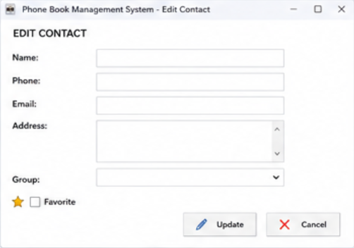
- Username: ô nhập tên đăng nhập.
- Password: ô nhập mật khẩu.
- Full Name: ô nhập họ và tên.
- Email: ô nhập địa chỉ email.
- Phone: ô nhập số điện thoại.
- Register: nút xác nhận đăng ký.
- Login: nút/chữ chuyển sang giao diện đăng nhập nếu người dùng đã có tài khoản.
-Thông báo lỗi: hiển thị khi dữ liệu không hợp lệ hoặc Username đã tồn tại.

2.3. Luồng tương tác
- Người dùng nhập đầy đủ thông tin vào các ô tương ứng và nhấn Register. Hệ thống kiểm tra dữ liệu.
- Nếu thông tin hợp lệ và Username chưa tồn tại, hệ thống tạo tài khoản mới trong bảng accounts và thông báo đăng ký thành công.
- Nếu thông tin không hợp lệ hoặc Username đã tồn tại, hệ thống hiển thị thông báo lỗi và yêu cầu người dùng nhập lại.
- Nếu người dùng đã có tài khoản, chọn Login để chuyển sang giao diện đăng nhập.

3. Login/Logout Interface
3.1. Mô tả giao diện
- Giao diện Login dành cho cả User và Admin để truy cập hệ thống. Đây là giao diện đầu tiên người dùng sử dụng sau khi khởi động hệ thống.
- Giao diện cho phép người dùng nhập thông tin tài khoản để hệ thống xác thực và xác định quyền truy cập.
3.2. Thành phần giao diện
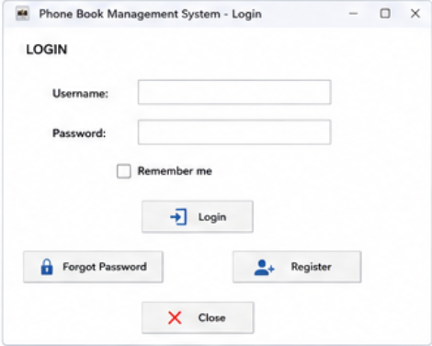
Username: ô nhập tên đăng nhập.
Password: ô nhập mật khẩu.
Login: nút đăng nhập.
Forgot Password: chức năng tạo lại mật khẩu khi quên mật khẩu.
Register: chuyển sang giao diện đăng ký tài khoản.
Change Password: cho phép người dùng đã đăng nhập thay đổi mật khẩu.
Logout: nút kết thúc phiên đăng nhập.
3.3. Luồng tương tác
- Người dùng nhập Username và Password, sau đó nhấn Login.
- Hệ thống kiểm tra thông tin với dữ liệu trong bảng accounts. Nếu thông tin chính xác, hệ thống xác định giá trị role.
- Nếu role = User, hệ thống chuyển đến giao diện dành cho User.
- Nếu role = Admin, hệ thống chuyển đến giao diện dành cho Admin.
- Nếu thông tin đăng nhập không chính xác, hệ thống hiển thị thông báo lỗi.
- Khi người dùng chọn Logout, hệ thống kết thúc phiên làm việc và đưa người dùng trở lại giao diện Login.
4. Contact Management Interface
4.1. Mô tả giao diện
- Contacts Management là giao diện trung tâm để User quản lý danh bạ cá nhân. Giao diện hiển thị các Contact thuộc tài khoản hiện tại và cung cấp các thao tác thêm, chỉnh sửa, xóa và xem Contact.
- Giao diện chỉ hiển thị dữ liệu thuộc User đang đăng nhập dựa trên account_id.
4.2. Thành phần giao diện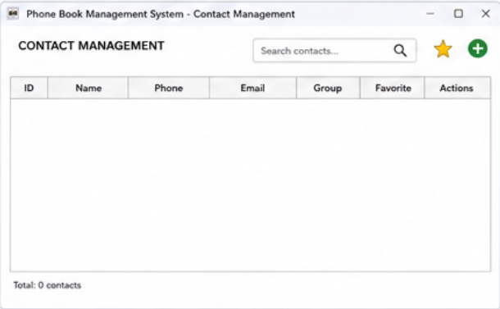
- Danh sách Contact: hiển thị các Contact.
- Dấu +: mở giao diện Add Contact.
- Dấu …: mở các thao tác đối với Contact, chẳng hạn Edit hoặc Delete.
- Biểu tượng kính lúp: chuyển sang Search Contacts.
- Biểu tượng yêu thích: chuyển đến hoặc thao tác với Favorite.
- Thanh tiêu đề: hiển thị tên chức năng hiện tại.
- Thông tin Contact có thể gồm:
+ Name
+ Phone
+ Email
+ Address
+ Group
+ Favorite
4.3. Luồng tương tác
User đăng nhập và chọn Contacts Management.
Hệ thống truy xuất các Contact có account_id tương ứng với tài khoản đang đăng nhập và hiển thị danh sách.
- Nhấn + → mở Add Contact.
- Nhấn … → hiển thị thao tác Edit/Delete.
- Chọn Contact → xem thông tin Contact.
- Chọn biểu tượng tìm kiếm → chuyển sang Search Contacts.
5. Add Contact Interface
5.1. Mô tả giao diện
Giao diện Add Contact cho phép User tạo một Contact mới và lưu vào danh bạ.
5.2. Thành phần giao diện
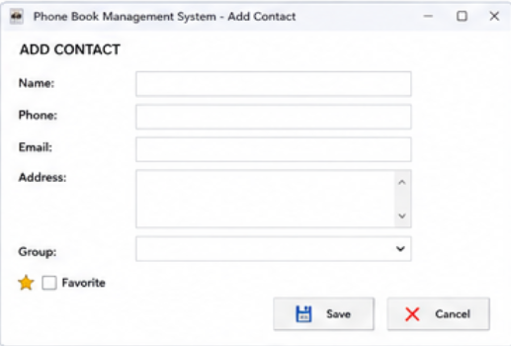
- Name: nhập tên Contact.
- Phone: nhập số điện thoại.
- Email: nhập email.
- Address: nhập địa chỉ.
- Group: lựa chọn nhóm.
- Favorite: đánh dấu Contact yêu thích nếu cần.
- Save: lưu Contact.
- Cancel: hủy thao tác.
- Nút Save là nút xác nhận thao tác chính, còn Cancel dùng để quay lại mà không lưu dữ liệu.

5.3. Luồng tương tác
- User nhấn dấu + trong Contacts Management.
- Hệ thống mở Add Contact. User nhập thông tin và nhấn Save.
- Hệ thống kiểm tra dữ liệu. Nếu hợp lệ, Contact được tạo và gắn với account_id của User.
- Nếu dữ liệu không hợp lệ, hệ thống hiển thị lỗi tại trường tương ứng.
- Nếu chọn Cancel, hệ thống quay lại Contacts Management và không tạo Contact.
6. Edit Contact Interface
6.1. Mô tả giao diện
- Giao diện Edit Contact cho phép User chỉnh sửa thông tin của Contact đã tồn tại.
6.2. Thành phần giao diện
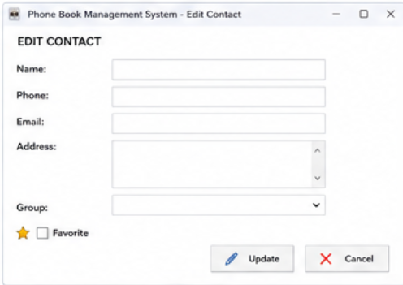
- Name
- Phone
- Email
- Address
- Group
- Favorite
- Update: lưu thông tin mới.
- Cancel: hủy chỉnh sửa.
6.3. Luồng tương tác
- User chọn dấu … hoặc biểu tượng Edit bên cạnh Contact.
- Hệ thống mở giao diện Edit Contact và hiển thị dữ liệu hiện tại.
- User thay đổi thông tin rồi nhấn Update.
- Hệ thống kiểm tra dữ liệu và cập nhật bản ghi tương ứng trong bảng contacts.
- Nếu User nhấn Cancel, hệ thống không thay đổi dữ liệu.
7. Delete Contact Interface
7.1. Mô tả giao diện
- Giao diện Delete Contact được sử dụng khi User muốn xóa một Contact khỏi danh bạ.
- Do thao tác xóa có thể làm mất dữ liệu, hệ thống phải hiển thị hộp thoại xác nhận trước khi thực hiện.
7.2. Thành phần giao diện
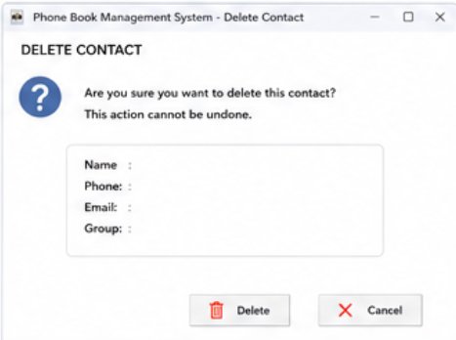
Giao diện/hộp thoại gồm:
- Tên Contact cần xóa.
- Nội dung xác nhận:
“Are you sure you want to delete this contact?”
- Confirm/Delete: xác nhận xóa.
- Cancel: hủy thao tác.
- Nút Confirm/Delete nên được thiết kế nổi bật để thể hiện đây là thao tác quan trọng; Cancel dùng để đóng hộp thoại.
7.3. Luồng tương tác
User chọn … → Delete.
Hệ thống hiển thị hộp thoại xác nhận.
- Chọn Confirm → hệ thống xóa Contact.
- Chọn Cancel → đóng hộp thoại và giữ nguyên Contact.
Sau khi xóa thành công, danh sách Contact được cập nhật và hệ thống hiển thị thông báo kết quả.

8. View Contact List Interface
8.1. Mô tả giao diện
Giao diện View Contact List cho phép User xem toàn bộ Contact đã lưu trong tài khoản.
8.2. Thành phần giao diện
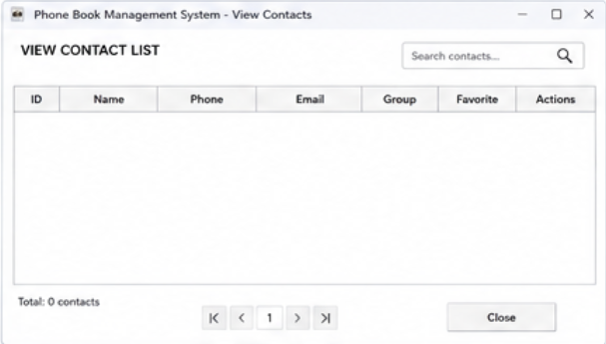
- Danh sách Contact.
- Tên Contact.
- Số điện thoại.
- Các thông tin cơ bản khác.
- Biểu tượng cây bút/Edit: chỉnh sửa Contact.
- Biểu tượng hoặc dấu …: mở thêm thao tác.
- Thanh tìm kiếm: hỗ trợ tìm Contact.
- Các tùy chọn sắp xếp nếu hệ thống hỗ trợ.
8.3. Luồng tương tác
User mở danh sách Contact.
Hệ thống lấy dữ liệu từ bảng contacts dựa trên account_id của User.
User có thể:
- Chọn Contact → xem chi tiết.
- Chọn biểu tượng cây bút → mở Edit Contact.
- Chọn … → thực hiện thao tác khác.
- Sử dụng Search để tìm Contact.
9. Search Contact Interface
9.1. Mô tả giao diện
Giao diện Search Contact cho phép User tìm nhanh Contact trong danh bạ thay vì phải xem toàn bộ danh sách.
9.2. Thành phần giao diện
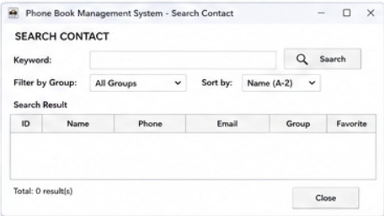
- Search Box: ô nhập từ khóa.
- Biểu tượng kính lúp: thực hiện tìm kiếm.
- Filter: lọc kết quả nếu cần.
- Sort: sắp xếp kết quả.
- Search Result: khu vực hiển thị kết quả.
9.3. Luồng tương tác
- User nhập từ khóa như tên, số điện thoại hoặc email vào Search Box.
- User nhấn biểu tượng kính lúp/Search.
- Hệ thống tìm kiếm trong các Contact thuộc account_id hiện tại và hiển thị kết quả.
- Nếu không có kết quả, hệ thống thông báo không tìm thấy Contact phù hợp.
10. Group Management Interface
10.1. Mô tả giao diện
Giao diện Group Management cho phép User phân loại Contact thành các nhóm để thuận tiện quản lý.
10.2. Thành phần giao diện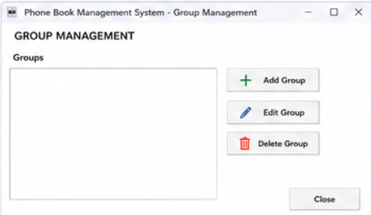
- Danh sách Group.
- Dấu +: tạo Group mới.
- Dấu …: mở thao tác Edit/Delete Group.
- Group Name: tên nhóm.
- Description: mô tả nhóm nếu có.
- Danh sách Contact thuộc Group.
10.3. Luồng tương tác
- User mở Group Management.
- Để tạo nhóm mới, User nhấn +, nhập tên Group rồi chọn Save.
- Để chỉnh sửa hoặc xóa Group, User chọn … bên cạnh Group tương ứng.
- User cũng có thể chọn Contact và gán Contact vào Group thông qua group_id.
11. Favorite Management Interface
11.1. Mô tả giao diện
Giao diện Favorite Management cho phép User quản lý các Contact quan trọng được đánh dấu yêu thích.
11.2. Thành phần giao diện
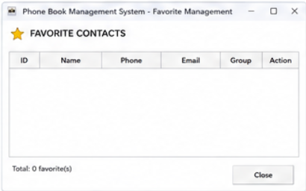
-Danh sách Contact yêu thích.
-Biểu tượng trái tim: thể hiện trạng thái Favorite.
-Biểu tượng thùng rác: xóa Contact khỏi danh sách Favorite.
-Thông tin Contact như Name và Phone.
11.3. Luồng tương tác
-User chọn biểu tượng trái tim của Contact để đánh dấu yêu thích.
-Hệ thống cập nhật thuộc tính isFavorite = true.
-Khi User chọn biểu tượng thùng rác, hệ thống bỏ đánh dấu yêu thích bằng cách cập nhật isFavorite = false.
-Danh sách Favorite được cập nhật lại mà không cần tạo bảng Favorite riêng.
12. User Account Management Interface
12.1. Mô tả giao diện
- Giao diện User Account Management cho phép Admin quản lý các tài khoản User trong hệ thống.
- Đây là giao diện dành riêng cho Admin, không hiển thị chức năng quản lý tài khoản cho User thông thường.
12.2. Thành phần giao diện
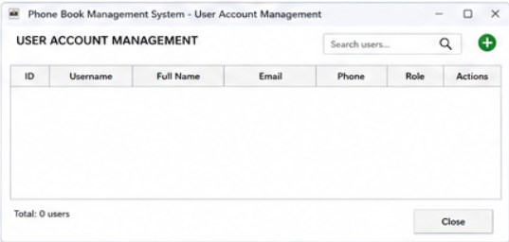
- Danh sách tài khoản.
- Account ID.
- Username.
- Full Name.
- Email.
- Phone.
- Role.
- Dấu +: thêm User mới.
- Dấu …: mở thao tác đối với User, chẳng hạn Edit hoặc Delete.
- Search: tìm kiếm tài khoản.
- Dấu … bên cạnh từng User dùng để mở các thao tác chỉnh sửa hoặc xóa User.
12.3. Luồng tương tác
- Admin mở User Account Management.
- Hệ thống kiểm tra quyền của tài khoản.
- Admin có thể:
- Nhấn + → mở giao diện thêm User.
- Nhấn … → chỉnh sửa hoặc xóa User.
- Sử dụng Search → tìm tài khoản.
- Xem thông tin và Role của User.
- Ngoài việc kiểm tra quyền trên giao diện, Backend vẫn phải kiểm tra role = Admin trước khi cho phép thực hiện các API quản trị nhằm ngăn User truy cập trái phép.
13. View System Reports Interface
13.1. Mô tả giao diện
Giao diện View System Reports cho phép Admin theo dõi các thông tin tổng hợp của hệ thống.
13.2. Thành phần giao diện
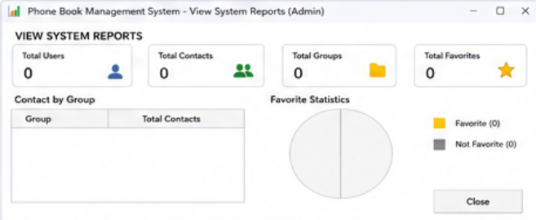
- Tổng số User
- Tổng số contact
- Tổng số Group
- Các thông tin thống kê khác
- Bảng thống kê
- Các số liệu có thể được trình bày bằng các ô thống kê hoặc bảng để Admin dễ quan sát.
13.3. Luồng tương tác
-Admin chọn View System Reports.
-Hệ thống truy xuất dữ liệu và tính toán các số liệu cần thiết.
-Kết quả được hiển thị trên màn hình dưới dạng bảng hoặc các khu vực thống kê.
-Admin có thể xem các số liệu để theo dõi tình trạng hoạt động của hệ thống.
14. Backup Data Interface
14.1. Mô tả giao diện
Giao diện Backup Data cho phép Admin tạo bản sao lưu dữ liệu của hệ thống nhằm bảo vệ dữ liệu và phục vụ cho việc khôi phục khi cần thiết.
14.2. Thành phần giao diện
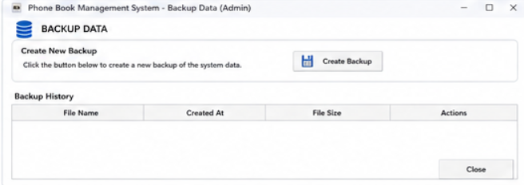
- Create Backup: bắt đầu quá trình sao lưu.
- Backup History: danh sách các bản sao lưu.
- Tên file backup.
- Thời gian tạo.
- Dung lượng file.
- Download: tải bản backup về thiết bị.
- Khu vực thông báo trạng thái.
14.3. Luồng tương tác
Admin mở Backup Data và nhấn Create Backup.
Hệ thống tiến hành sao lưu các dữ liệu cần thiết, chẳng hạn:
- accounts
- contacts
- groups
Sau khi hoàn thành:
“Backup completed successfully.”
được hiển thị.
Nếu xảy ra lỗi, hệ thống hiển thị thông báo lỗi và không làm thay đổi dữ liệu hiện tại.
Admin có thể chọn Download để lấy file backup về thiết bị.

15. Data Recovery Interface
15.1. Mô tả giao diện
Giao diện Data Recovery cho phép Admin khôi phục dữ liệu hệ thống từ một file backup đã được tạo trước đó.
15.2. Thành phần giao diện
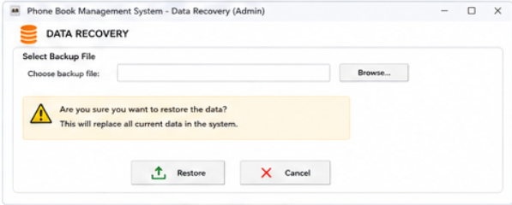
- Choose File: chọn file backup.
- Khu vực hiển thị tên file đã chọn.
- Restore: bắt đầu khôi phục.
- Cancel: hủy thao tác.
- Hộp thoại Confirm trước khi khôi phục.
- Khu vực thông báo kết quả.
15.3. Luồng tương tác
Admin nhấn Choose File và lựa chọn file backup từ thiết bị.
Hệ thống kiểm tra file:
- Nếu file hợp lệ → cho phép thực hiện Restore.
- Nếu file không hợp lệ → hiển thị thông báo lỗi và không khôi phục.
Admin nhấn Restore.
Hệ thống hiển thị:
“Are you sure you want to restore the data?”
Nếu Admin chọn Confirm, hệ thống tiến hành khôi phục dữ liệu.
Nếu chọn Cancel, quá trình khôi phục bị hủy và dữ liệu hiện tại được giữ nguyên.
Sau khi thành công, hệ thống hiển thị:
“Data recovery completed successfully.”

